Web Scraping and Data Visualization Report
Purpose
The purpose of this script is to extract employee information from a web page, store it in a structured format (CSV), and generate visual insights based on the distribution of department and job title.
_____________________________________________
Workflow Overview
The script follows a classic ETL (Extract, Transform, Load) pipeline:
1. Extract data from a structured HTML table on a specified web page.
2. Transform the raw HTML data into a clean list of employee records.
3. Load the cleaned data into a CSV file.
4. Visualize the department and job title statistics using matplotlib.
_____________________________________________
Data Extraction
The function fetch_employee_info() uses the requests and BeautifulSoup libraries
parse an HTML table from the URL:
http://darkmind.uk/SCRAPESITE/employees.html
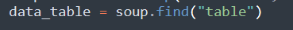
Export to CSV
The function export_to_csv() writes the scraped list to a file named employees.csv.
This creates a properly labeled CSV file, ready for spreadsheet tools or further analysis.
Data Visualization
The function generate_report() creates two visual representations:
Bar Chart – Employees by Department
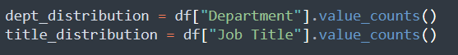
This chart helps identify how departments are staffed. Here's an example output layout:
Bar Chart – Employees by Department.
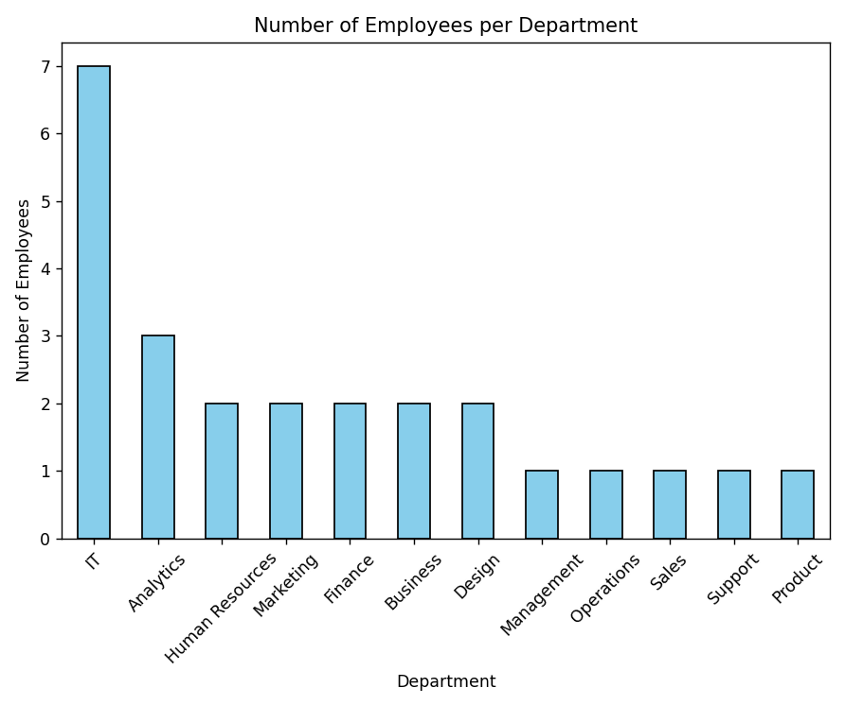

Pie Chart – Distribution by Job Title
A pie chart shows how job roles are distributed across the company.
Example Output:
Pie Chart – Job Title Distribution
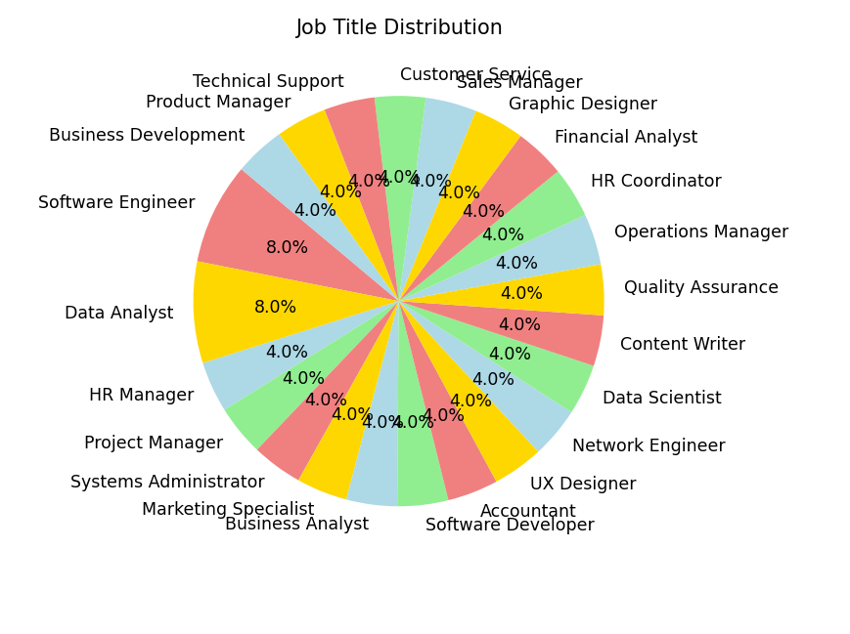
Script Strengths
• Strong error handling: Try/except blocks ensure that the program does not crash on a bad URL.
• Clear separation of concerns: Each function has a well-defined responsibility.
• Modular and easy to maintain: Easy to extend (e.g. additional fields, new graphics).
Suggestions for improvement
• Add logging instead of using print() for better monitoring.
• Consider pagination or handling multiple tables if the website expands.
Provide an optional argument to save the graph to disk (for automation/reporting).
Conclusion
This Python script is a robust and efficient application for web scraping and visual reporting. Demonstrates practical use of BeautifulSoup for analysis and matplotlib for visual storytelling. Supports integration with other systems or manual analysis by exporting to CSV.

